NAME:__________________________________________________________ PD:___________
Chapter 4 Section 1 Guided Reading
The Gift of the Nile
Location and Physical Features  - Describe the two regions of Ancient Egypt  - Upper Egypt  Southern Egypt, start of the Nile River  - Lower Egypt  Northern Egypt, ends in Mediterranean Sea, has a delta  - How did cataracts affect travel in Egypt?  It blocked travel in South Egypt (Upper Egypt) and protected them from invasion  - What is a delta and why was it important? (Think about how much farmland was there)  Triangle-shaped area at end of a river with good soil for farming | The Floods of the Nile  - What was the effect of the Nile’s flooding on its land?  Flooding came every year, and left great soil for farming  - What was “the black land” and “the red land”?  - “the black land”  Dark soil with silt left by flooding of the Nile  - “the red land”  Dry, desert soil, can’t farm it.
Civilization Develops in Egypt
Increased Food Production  - What did Egyptians do differently than Mesopotamia to use water for farming?  Didn’t have to build basins  - What crops (and animals) did Egyptians raise?  Wheat, barley, fruit, vegetables, cows, sheep | Two Kingdoms  - Why was it hard to invade Egypt?  The Red Sea, natural barriers (mountains, seas), desert  - How did Egypt develop into two kingdoms?  Villages in the North and South banded together to form two kingdoms  - What were the names of the two kingdoms?  Upper Egypt and Lower Egypt
Kings Unify Egypt
- How did Menes combine the two kingdoms?

He was in charge of Upper Egypt, invaded Lower Egypt and married a princess from Lower Egypt

- What is a pharaoh and how is a pharaoh part of a dynasty?

Pharaoh – King in Egypt
Dynasty – when a family rules a kingdom or empire

- How far did Egyptian territory extend?

All along the Nile River, about 50-100 miles on each side

LABEL THE FOLLOWING FEATURES (Use page 89 in textbook)
Nile River
Nile Delta
Upper Egypt
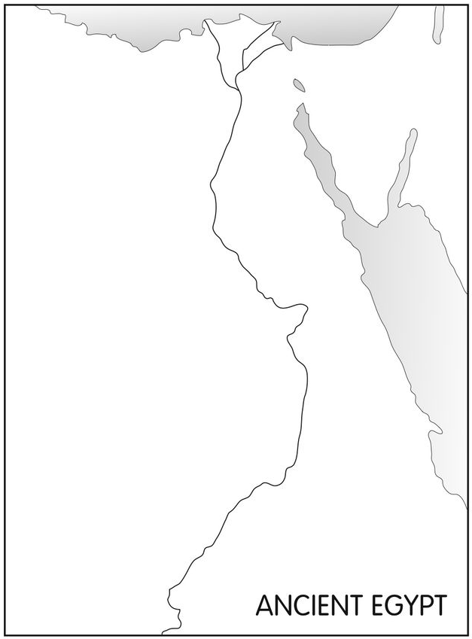
Lower Egypt
Sinai Peninsula
Red Sea
Mediterranean Sea

